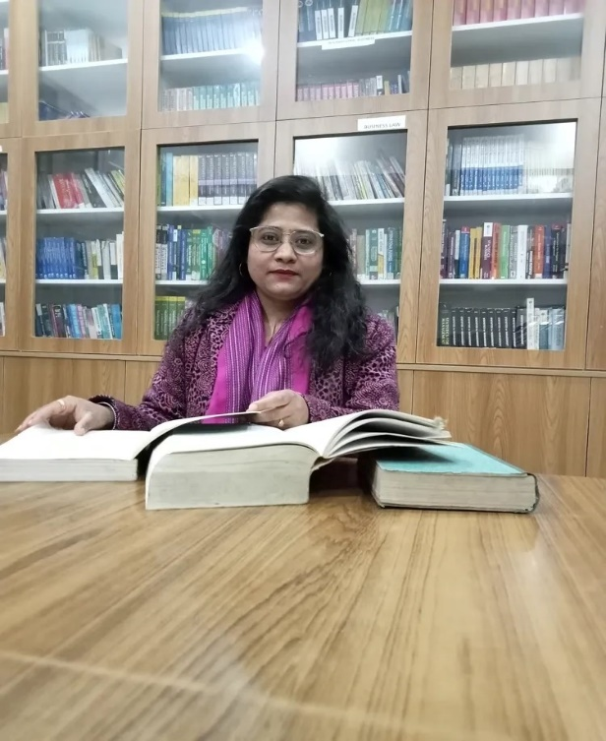

Nupoor Bhandari
Assistant professor in Nimbus School of Education
Area
Primary Area: Education
Secondary Area: Accounting, Finance, Auditing

Contact
Email: Nupoorbhandari27@gmail.com
Phone: +91-9997477910

Education
- Fellow Program in Education (Doctoral Degree), Himgiri Zee University
- Qualify NTA-NET in Education
- Qualify CTET 1 & CTET 2
- Master of Education, Birla campus Srinagar (HNBGU)
- Bachelor of Education, Army Institute of Education (GGSIPU)
- Master of Commerce, Bachelor of Commerce

Teaching
- Education
- Finance
- Guidance and counselling
- Management Accounting
- Corporate Accounting

Research Area
Sustainable development and vocational education
Information Communication Technology for Education
Guidance needs of students in the Indian context
Green skills and vocational education
Various psychological aspects

Academic Experience
Faculty Member, Nav Chetna College, Dehradun, January 2021 onwards
Faculty Member, Nimbus School of Education, September 2022 onwards

Professional Experience
Nimbus School of Education
Nimbus Academy of Management

Selected Publications

- Research Paper entitled “The Inquiry of Vocational Education: In the Legacies of Dewey, Tagore, Gandhi” Published in the International Journal of Analytical and Experimental Model Analysis (IJAEMA) February 2023. (PP: 55-68) ISSN NO:0886-9367
- Research Paper entitled “Green Skill Awareness and its Importance in Vocational Education: The Indian Scenario” Published in the book Green Solutions: A Handbook for Sustainable Business Strategies February 2024. (PP: 235-243) ISBN: 978-81-971276-6-3
- Research paper entitled, “The Global 2030 Agenda: Vocational Education and Sustainable Development Goals in the Indian Context” in Intersectionality in Education: Promoting Equity Inclusivity and Sustainability ISBN: 978-91-989240-1-5

Academic Conferences

- Research paper presentation in National seminar organized by SGRR in September 2023 entitled “Guidance need of adolescent students studying in government and private secondary school”.
- Research paper presentation in a Virtual first international conference organized by CTPD- DELHI in October 2023 entitled, “The Global 2030 agenda: Vocational Education and Sustainable Development Goals in the Indian context”.
- Research paper presentation at a national conference organized by Lakshmi Devi Tamta Women Education Center, Soban Singh Jeena University, Almora on the topic of changing dimensions of women's world in December 2023 paper entitled “Empowering women for the stronger economy through skill development and vocational education”

FDP attended

- Participation in a five-day national virtual faculty development program on AI in education and business organized by the Department of Business Administration, Hindustan College of Arts and Science in January 2024

- Participation in a one-week National level virtual faculty development program on Use of Artificial Intelligence in Education 4.0 organized by Career Development Cell (CDC), Gokul Global University, Siddhpur, Gujarat from 8 to 14 January 2024

